OBJECTIONS in Relation to SSI-10033
(Shoalhaven Hydro Expansion Project – Main Works)

In relation to SSI-10033 (the Proposed Project) submitted by Origin Energy Eraring Pty Ltd, with Jacobs Group (Australia) Pty Limited (the Proponent), the following general and specific objections are noted for consideration by the Consent Authority as provided for in the NSW Environmental Planning and Assessment Act 1979.

- Onerous expectation, incumbent upon local residents/private landowners/community members, to provide comment in relation to the Proponent’s EIS and accompanying 17 Appendices within the minimum legislative requirement of 28 days public exhibition. There are estimated to be over 2,000 pages comprising these documents.
The documentation appears fundamentally flawed and misleading in the presentation of not only the Proposed Project concept and description, indicative layout and project location but also the identification of impacts and associated mitigation requirements, which appear either incomplete, cursory or misleading, or a combination of these. Further detail and specific objections in relation to these issues are outlined below.
In addition, the specialist technical expertise required to comment on the full proposal and implications is understandably outside the scope of any one individual. Community members are also providing feedback in their own time while experiencing the mental anguish and worry associated with this proposal, unlike the multiple people paid to develop the concept and prepare the proposal documentation.
Considering this, any public submission cannot realistically expect to be fully cognisant or comprehensive of all the possible objections, non-compliance matters, omissions or falsifications contained in the Proponent’s documentation and representation of the Proposed Project.

- Non-compliance of the EIS and associated documentation with a number of legislative provisions and in particular the SEARs requirements as provided for by the NSW Environmental Planning and Assessment Act 1979 (Section 5.16) and the EP&A Regulations 2021, as well as other applicable policies and guidelines. Some specific examples in relation to this area of objection are provided below.

- Fundamental flaws and misleading information in the Proponent’s documentation. This includes use of out-of-date data, lack of context and local data, non-specific maps and omitted data sets. Other public submissions from community members and stakeholders also highlight deficiencies in this regard and failures by the Proponent to meet legislative requirements in the production of the EIS and associated documentation.
One critical example of the use of misleading and deceptive data is the description of the location of the proposed project in relation to existing residences and businesses. The scale and age of maps and diagrams used repeatedly for the Project Location, Indicative Project Layout and other visual representations of the Proposed Project’s infrastructure locations imply, by omission, that there are no existing buildings and residences impacted upon, specifically in relation to Jim Edwardes Place, Jacks Corner Road and Lower Bendeela Road. In doing so, the Proponent also makes the fallacious claim of ‘Greenfield’ development (also noted in Point 13 below) and deceptively seeks to downplay direct, and indirect, impacts of the development, particularly in relation to existing private residences in the primary study area of the EIS.
This is in direct contradiction of the following SEARs General Requirement as contained in ‘Issued SEARS’ listed on the Department’s SSI-10033 webpage:

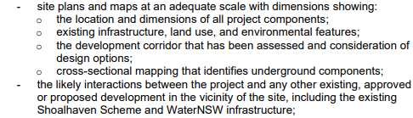
Additionally, and specifically, the following General SEARs has not been complied with by the Proponent (further extract from ‘Issued SEARs’)

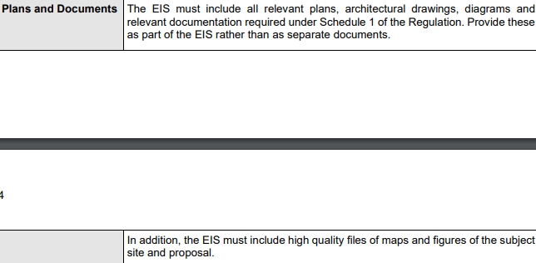

- Failure to comply with SEARs General Requirement and disclose capital investment value as noted in the aforementioned ‘Issued SEARs’:
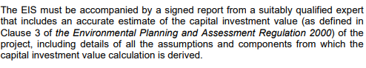
The Proponent states in Appendix A SEARs compliance table “A report by a suitably qualified expert has been provided separately to DPE”
Therefore, it is impossible to comment on the Proposed Project’s cost/benefit without the Capital Investment Value report being available. There is no information contained in the Project Proposal regarding indicative or overall project costs, investment sources or government funding support – even as a ratio of total indicative project cost. Nor is there any analysis of the value of the proposed 235 MW generation within the NSW renewable energy market or the NEM and therefore overall ‘community benefit’.

- Objection to the Proponent’s reference to, and suggestion of ‘Temporary Impacts’ throughout the EIS - of great concern due to the fallacious and dismissive documentation. How can a 5 Year construction timeframe, as stated by the Proponent (which will realistically be longer, given delays and overruns are well known to occur with large scale construction projects), be considered ‘temporary’ for residents, community members and wildlife?
Further, the construction phase is proposed to be undertaken 24 hours per day, 7 days per week. The Proponent states ‘the Project is expected to directly create approximately 250 FTE jobs over the five-year construction phase’ (EIS p 194), there is no detail in relation to how this figure of 250 FTEs over the ‘life’ of the project has been determined – is this estimate accumulative over the duration of the 5+ Year construction phase or consistent throughout? There is also reference to a ‘peak construction period’ which, apart from being described as increasing FTEs from approximately 250 to ‘about 370’ ((ibid) is not specified in terms of duration i.e. unknown/unspecified.
Notwithstanding, any reference to ‘temporary impacts’ is misleading and deceptive.
The EIS requires significant review and revision to adequately identify the Proposed Project’s real impacts, the scale of these impacts and corresponding mitigation strategies (refer to Point 10 below) for any genuine assessment and/or consideration of approval to be undertaken by the NSW Minister for Planning.

- Environmental impacts of a 5+ Year 24/7 construction phase on wildlife, habitats and biodiversity in an area renowned for its unique environmental features and values. Kangaroo Valley is considered an area of unique environmental value, natural beauty and abundant wildlife, attracting people to live, work, retire and visit.
The Proposed Project appears to fail in addressing the requirements relevant to the Environment Protection and Biodiversity Conservation Act 1999 (EPBC Act) and contained in the Supplementary SEARs (listed on the Department’s SSI-10033 webpage) which identifies the specific Requirement in relation to:
i. listed threatened species and communities (sections 18 and 18A)

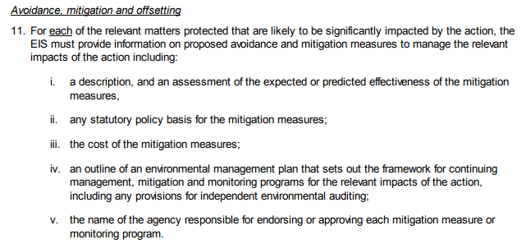
The Project Proposal demonstrates no evidence of mitigation measures (as the Proponent states these will be developed at some future time – refer to Point 10 below) nor is the cost of mitigation disclosed or other elements of the above Supplementary SEARs addressed as required.

- Based on the documentation provided, it is difficult to assess or ascertain, the extent to which the Proponent has met the following applicable SEARs General Requirement of:

While the Consent Authority remains incumbent to assess and verify the accuracy and compliance of the Project Proposal, it is submitted that within the available timeframe for public comment, this is a matter that warrants further investigation and evidence to demonstrate compliance by the proponent with SSI legislative requirements/minimum standards.

- Community impacts of a 5+ Year 24/7 construction phase on immediate residents and businesses, or ‘sensitive receivers’ as termed by the Proponent, who also failed to fully identify all parties in this category during engagement and preparation of the EIS – amongst other deficiencies. Some of the Proposed Project’s direct impacts include Noise, Vibration, Dust etc, Traffic, Noise, Air quality and Property values, as well as the Proponent’s noted ‘potential’ for, and of, sleep disturbance (continually over 5+ Year construction phase?) with corresponding and associated mental health impacts on immediate residents, and some within the primary study area – all impacts stated in the Proponent’s documentation. The assessment of these impacts, including the mental health and wellbeing impacts, remains cursory, non-specific and therefore dismissive – consistent with the overall presentation and content of the Proponent’s documentation.
Neighbouring residents, businesses, and local communities will also experience these impacts along with significant community-wide impacts on tourism, accommodation and housing availability, economic participation opportunities, traffic and road conditions, noise etc.
Many of the specific aspects of these impacts are well documented in other public submissions from community members and stakeholders.

- Failure to comply with community engagement requirements and adherence to the SEARs General Requirement and specifically the Department’s Guidelines for SSI Engagement. The Proponent’s EIS Appendix D Community Engagement represents dismissive documentation of community concerns raised and fails to evidence the current and cumulative mental anguish being experienced by residents and businesses directly impacted by the Proposed Project. Inclusion of any community engagement related to the 2019 project proposal is misleading and fallacious given the Proposed Project bears very little resemblance to the 2019 proposal, including the direct use of, and impacts, on privately owned land (albeit sub-surface). Unfortunately, time constraints (refer to Point 1 above) prevent further expansion on this specific area of objection. However evidence of the basis for this objection is clearly apparent and also well documented in other public submissions from community members and stakeholders.

- Failure to comply/ non-compliance regarding SEARs requirements for general and specific Mitigation Measures. The Proponent’s documentation provides no, none, or any detail of mitigation strategies. All documentation in relation to mitigation measures refers to ‘X’ Mitigation Plan’ will be developed.
This is in direct contradiction to the legislative requirements – both generally, and specifically, and as related to SSI’s. Again, time constraints (refer to Point 1 above) prevent further expansion on this specific area of objection. However evidence of the basis for this objection is clearly apparent and also well documented in other public submissions from community members and stakeholders.

- Cursory dismissal of any, and all, project impacts in relation to the Operation of the Proposed Project, once constructed in 5+ Years, as though any operational impacts will be the same as the Existing hydro scheme. It is difficult to understand how this would be the case given the ‘expansion’ of associated infrastructure and increased footprint. For example, any operational ongoing impacts of the proposed new ventilation and access tunnel as well as a new tailrace are dismissed as negligible, despite there being no design details provided in the proposal. Without sufficient details, design plans and technical specifics i.e. the Proposed Project being developed past a current ‘conceptual’ phase (by the Proponent’s own admission – refer to EIS), any conclusions presented by the Proponent regarding Operational impacts appear fundamentally flawed and assumptive.

- Proposed generation of 235 MW when there are many other proposals and approved projects that offer higher energy generation capacity, less direct impacts (particularly for residents and unique biodiversity locations) and greater government funding return on investment and overall public benefit. Public submissions from other community members and stakeholders provide greater detail and analysis of this area of objection.

- Cursory and dismissive treatment of the SEARs requirement for analysis of Project Alternatives/Options.
Pages 26-28 of the EIS describe seven (7) possible Project Options, summarised at Table 2.2, highlighting the scant analysis undertaken. In addition, Table 2.2 suggests that the chosen Option 5 has the chosen ‘value driver’ of ‘Min. disruption’ which is clearly not the case for the Proposed Project involving minimum 5 years construction 24 hours/day 7 days/week, as outlined in this submission, and many others from the impacted community. Also, to suggest Option 5 is a ‘Greenfield’ development is simply not true.
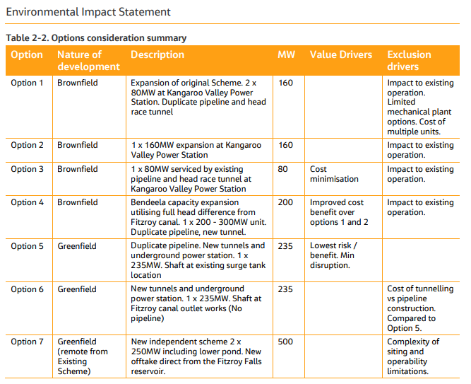

In relation to the general and specific objections raised above, the Proposed Project represents an overly negative outcome in terms of general, and specific impacts and is definitely not able to be considered in the public interest in terms of energy generation or public funding for renewable energy in NSW and Australia’s NEM, based on the Proponent’s documentation available.

On a personal note, clearly our property – my parent’s property and their retirement home, is directly impacted by the Proponent’s Proposed Project.
The NEGATIVE IMPACT of the Proposed Project is significant, notwithstanding our current personal circumstances (individual, family and community) – because for anyone, at any time, in any circumstances, this is an unnecessary SSI. There are better options to achieve our community goals of improved sustainability in energy generation for all of us - with all of us considered.

Regards
Karyn Apperley, C/- 40 Jim Edwardes Place Kangaroo Valley NSW

